US Bank – Disability Center Scholarship

Established in 2011, this fund provides scholarships to students registered with the Disability Center at the University of Missouri. Applications are accepted during Spring semesters.

Application materials will be reviewed by a committee to determine recipients. The committee will take into consideration academic accomplishments, involvement, and leadership characteristics. This scholarship has been made possible by a donation from US Bank.

To qualify, an applicant must meet the following criteria:

- Be a student at the University of Missouri
- Currently be registered with the Disability Center
- Have a minimum Cumulative GPA of 2.0
- Must not be on academic probation.

Application Deadline: March 29, 2024
Academic Year: 2024-2025

Application form on the reverse.
For more information, contact:

Disability Center
University of Missouri
S5 Memorial Union
Columbia, MO 65211
(573) 882-4696 Phone
(573) 234-6662 VP
(573) 884-5002 Fax
mudcscholarships@missouri.edu

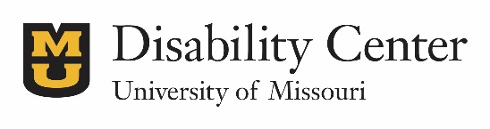

Disability Center Scholarship
All application materials must be submitted by March 29, 2024 by 5 pm to be considered
Please return to the Disability Center (S5 Memorial Student Union) in person or e-mail to mudcscholarships@missouri.edu
Student Information

Full Name: Student ID Number:

Campus/Local Address:

Campus/Local Phone: Email:

Permanent Address:

Academic Information

Degree Program:

Current Cumulative/Adjusted GPA: Credit hours earned:

Anticipated Graduation Date:

Letter of Application
With your application please provide responses to the following questions in the form of a typed letter to the “scholarship selection committee”. Please answer each question clearly and specifically with all relevant details provided.
- Please discuss your accomplishments and involvement at MU. Please include information regarding academic achievements, employment, volunteer work, student organizations. Please discuss your involvement with the Disability Center.
- If you are awarded this scholarship, how will it benefit you in your educational pursuits?
- How and what type of leadership characteristics do you model to other MU students with disabilities?

Please attach the following items to this application:
(Neglecting to include these will result in your application not being evaluated.
- A Current Resume
- Two Letters of Recommendation

Verification of Information/Academic Release
My signature below verifies that the information contained in this application is correct to the best of my knowledge. To be considered for the scholarship, I authorize The University of Missouri to release my academic records to the members of the scholarship selection committee. Recipient will be recognized publicly. In signing, I give my permission for my name to be released if I am awarded a scholarship.

Signature: Date:

______________________________________________________________________________________
S5 Memorial Union, Columbia, MO 65211 | 573-882-4696 | disabilitycenter@missouri.edu

